Day Fines in the United States

Roy Rashke

Tiffin University

Many Americans have claimed that the use of the standard fine scale oppresses the poor and encourages the wealthy to commit crimes. After considering the research done in other countries it has become apparent that the use of such a scale can dissuade the wealthy from committing crimes on multiple different levels. The research done will include opinions about different aspects of the day fine system and various offenses. The data collected will be presented and an explanation of how the use of a Day Fine-scale can and will be beneficial to the United States will be provided.

Introduction:

Statement of the problem

Many people in America think that fines being paid are too much with several countries in Europe use alternative systems for fines instead of monetary funds my partner and I decided to conduct research about how a sample of college-age students would react to implementing a day fine system in the United States.

Literature review:

Graduating Economic Sanctions According to Ability to Pay

In recent years the use of the tariff fine system has come into question, this is because many Americans are realizing how they impact people of certain lower economic backgrounds more than those with a higher economic background. “Tariff-fines are inherently regressive, having a greater effect on the financial condition of a person of limited means than on a person of wealth (Colgan, 2017). This demonstrates that the current fine system is biased towards those with lower economical means. The lower a person’s income, the harder it becomes for them to pay a fine such as a speeding ticket. While if someone has a higher income such a ticket or fine is a minor inconvenience to their everyday life. This is where the day fine scale offers a different approach.

         The day fine scale actually takes a person’s finances into account, so that if fined a person of a lower economic background is not being forced into debt. “At the same time, day-fines were understood to be more equitable because they accounted for the defendant’s finances” (Colgan, 2017). This indicates how beneficial the day fine scale would be to the public, because it would allow citizens to retain some of their wealth instead of having to pay a hefty fine that could lead them into debt.

The day fine system could also decrease the incarceration rate in the United States. “Second, in cases where either tariff fines or other forms of punishment were available, the perception that a given defendant had a limited ability to pay could push judges to opt for a sentence of incarceration or probation” (Colgan, 2017), which demonstrates that getting rid of the tariff fines could allow for a decrease in incarceration rates. The decrease in incarceration rates as well as taking an individual’s economic status into account would greatly benefit the United States.

The Constitutionality of Income-Based Fines

The United States fine system not only keeps American citizens in debt, it also puts them into prison. In the United States if a person is not able to pay a fine, it could lead to the possibility of jail time. The court system will typically issue a warrant for the individuals arrest if a fine is not paid, and if the individual is still not able to pay the fine, they will be sentenced to a certain amount of time in jail. “Across the country, courts commonly levy steep fines on those without the means to pay and then respond to nonpayment with arrests, court proceedings, and periods of incarceration” (Schierenbeck, 2018).

This demonstrates how using the American fine system can lead to varying levels of incarceration. The increase of citizens being incarcerated because of this system can also lead to the government wasting funds on prisons, which could instead be used on roads or schools. The utilization of the day fine system would not only decrease government spending on prisons and allow for those resources to be used for better causes, it could also increase government revenue. “Some of this increase could come from progressivity at the upper end: in the Staten Island experiment, for example, estimates are that revenue from fines would have increased by nearly 80 percent during the demonstration project had relatively miserly statutory maximums not constrained collection from higher-income offenders” (Schierenbeck, 2018).

This demonstrates that the government could increase its resources very quickly because the wealthy would be fined at a higher rate, compared to the standard rate of a few hundred dollars. It is also possible that the governments resources could increase by using the day fines because it would allow low income offenders to be able to actually pay off their fine. “And even without steep progressivity, income-based fines could boost revenue by increasing the rate at which low income offenders pay their debts—as fine amounts become more manageable, offenders may make greater efforts to complete payment” (Schierenbeck, 2018). This demonstrates that if the day fine scale was used it is likely that low income offenders will be able to pay their fines, instead of receiving jail time, thus increasing government revenue.

The Value of Remorse

         The day fine system would not only increase government revenue, but it may also allow American citizens to be fined fairly for the offense that was committed. The most common fine an individual may receive is for a speeding offense. These speeding tickets can vary in amounts depending on the state the individual is in, as well as how fast the individual was going when they were pulled over. The fines used are typical of the American sliding scale system, but officers are actually able to increase an individual's fine for a variety of reasons. “In most jurisdictions, police ofﬁcers can also exercise discretion” (Day & Ross, 2011).

This demonstrates that while there are set fines that can be issued, the officer is able to make an executive decision and change the fine to whatever they think is appropriate. The officer may increase the fine for a good reason such as if an individual is not wearing a seatbelt.

Unfortunately, it is also possible for the officer to increase a fine depending on how the individual treats the officer during a traffic stop. If this is the case, it is incredibly unfair to the individual especially if they are of a lower income background, where they may not be able to afford an increase in the standard fine. A study was conducted to see how officers issued fines for speeding, and if there were other factors involved in determining the amount of the fine. “We expected that drivers’ speed over the limit would be the main predictor of ticket costs” (Day & Ross, 2011).

This indicates that the hypothesis for this study was that the speed an individual was going was going to be the main predictor of how much the fine would amount to. The study involved multiple ages of different genders, races, and economic backgrounds. The study concluded that if an individual showed remorse for speeding the officer was more likely to be more lenient when issuing a ticket or warning. “Expressions of remorse were associated with a reduction in ticket costs and a greater likelihood of receiving a warning rather than a ﬁne” (Day & Ross, 2011).

This indicates that instead of going off of how fast an individual was going to predict the fine, officers may go off of a person’s demeanor when pulled over. If an officer did not think that the individual was remorseful, they may impose the highest fine possible. This can lead to people of lower economic backgrounds ending up in debt over a fine that was issued just because they did not seem remorseful enough when they were pulled over. The use of such decisions by officers could also lead to a higher incarceration rate, especially if they imposed the max fine on an individual with a lower economic background who could not afford the fine, resulting ultimately in that individual having to serve jail time.

Policing and Punishment for Profit

         The practice of imposing a fine for an offense has been in use since the creation of early civilizations, the use allows for people to avoid going to jail or prison and also generates revenue for the government. In recent years however, some governments and police departments have been imposing fines at an incredibly high rate, just to garner additional revenue. “When the investigation revealed that police officers had been given orders to write at least 12 tickets during each 12-h shift or face repercussions, violating Florida state law that prohibited ticket quotas, Waldo’s city council voted to disband the police department” (Surprenant, 2019).

This demonstrates how a police department in Florida was requiring its officers to write a certain number of tickets to increase revenue. This is an unacceptable use of the fine system, especially because Americas fine system does not take one's economic background into consideration. If a police department is required to give out a certain number of citations, they most likely do not care who they fine or if that individual can pay the fine. While if a day fine scale was instituted forcing officers to write a certain number of tickets would still be unacceptable, but the citizens fined would be likely be more able to pay the fine, and not be incarcerated for failure to pay.

Borrowing from Consumer Law To Combat Criminal Justice Debt

The continued use of Americas sliding fine scale system has led to an increase in debt for many American citizens. “The last thirty years have seen dramatic growth in civil consumer debt and criminal justice debt, as well as abuses associated with the collection of such debts” (SOBOL, 2017). This demonstrates how the United States has seen an increase in debt due to its use of the sliding fine system.

Those that are in debt because of the criminal justice systems use of this scale are the object of many adversities. “Not only do individuals with criminal justice debt encounter the same abuses and consequences that consumer debtors face - including harassment, negative credit reports, and the adverse impact on financing and employment prospects - but they also face denial of welfare benefits, suspension of driver's licenses, arrest, and incarceration” (SOBOL, 2017). This demonstrates the different adversities many Americans face when they are in debt due to failure to pay a fine. It also demonstrates that if America adopted a day fine system instead it could lower the increasing debt rate, as well as save many Americans from having to deal with these adversities, because they would most likely be able to pay the fines levied against them.

The use of the sliding scale also as mentioned before increases rates of incarceration within the United States prison system. “On any given day, over 450,000 people in the UnitedStates are incarcerated without having been convicted of an offense” (SOBOL, 2017). This indicates that the incarceration rate is increasing just because citizens are not able to pay their fines or post bail. This then in turn leads to the government having to spend more money on resources for jails and prisons when those funds could be used for something more beneficial to society. The current fine and bail rates are set to act as a deterrent to those that may commit a crime, with the reasoning being if they have to pay a large amount of money for an offense, they are less likely to commit the offense in the future.

While this can act as a deterrent, it usually ends up with individuals being placed in jail for failure to pay their fine. If the day scale was implemented it would allow the individual to pay their fine because it goes off of that own individual’s income.The day fine scale would also act as a deterrent because depending on the offense, the fine could be raised to a higher day unit thus requiring the offender to pay a hefty fine while still taking their economic status into account.

Unpaid Work as An Alternative

Several places all around Austria and Scotland use various methods of disciplining someone. These two countries sought a way to decrease the average number of fines given out to their citizens and came up with other non-custodial methods of disciplining someone which is unpaid work. Scotland has been doing unpaid work as a sentence for significant offenses for the past twenty years while Austria has started doing community service and community work for free in order to pay a debt to society. Community service has been used as a form of punishment in several different countries for many years. The first ever countries to use community service to deter criminality were Switzerland, Italy and Germany, which began in 1986. Spain followed close behind these countries with implementing community service as a punishment in 1995 when they official added it to their criminal code. In 1980, rising numbers and overcrowding in prisons due to fine nonpayment began the search for alternative sentences for criminal activity and Switzerland was in the forefront of developing alternatives according to the Secretary of State for Switzerland (McIvor, Pirnat, & Grafl, 2013).

With several different groups influencing policy changes in Scotland during this period the Law Reform act of 1991 came into effect which gave the power to argue fines and impose fine limits to the Office of Social Work. Many of the service hours that Scotland gives out instead of fines occur around the amount of 30 hours or less. The alternative to doing community service currently in Scotland is imprisonment until wages are made that are equal to your fine. The current fine scale puts many level two offenses such as criminal infractions about 500 pounds which is the equivalent of 650 dollars in the United States.

The most recent change to Scotland’s policy regarding localized management of fines took effect in 1998 when the Office of President made a Scotland Executive order changing how fines were made and dealt out to offenders. The model currently in effect typically includes community service among the evening hours and during the weekend so one could hold a regular day job and have the weekends off to complete community service.

Swedish Day fines

Sweden looks at fines in a purely Economistic way. They pose the question, what would happen if instead of fines being assessed the criminal justice system just convert the fines into how much time it would take to you to earn that amount and lock the offender in jail for that many days. Sweden’s criminal justice system claims, “We are quite accustomed to assessing the bad that people have done in temporal terms so why not just add the fine in temporal terms to their sentence as well” (Eriksson & Goodin, 2007). That being said inmates could earn time off for good behavior as the equivalent of getting a bonus at work in terms of money. The whole basis of Sweden’s Day fine system is to give people yet another way to make amends for a crime they committed.

Sweden looks at several different factors when deciding whether or not to assign a day fine or convert it to a jail sentence for the same amount owed. The first one being money problems. Even at the current day fine structure is it still hard for the offender to pay for the fine. If the answer to that is yes, then the Swedish court may decide on alternative measures. The second factor Sweden looks at is Temporal Measures. Would the offender be better served to pay for their crimes with a monetary fine or longer jail sentence to think about their crimes?

The main reason Sweden looks for alternatives for fines then a regular fine system is because $1000 dollars means much more to a poor person than to a rich person (Eriksson & Goodin, 2007). That leads Sweden to the basis on how they determine what fine to assess, “One day-fine is intended to equal what the fined person, taking into consideration his or her economic circumstances, would be able to abstain from every day, for a long time, without being deprived of the necessities in life or fail in his or her duties to those dependent on him or her.” (Eriksson & Goodin, 2007).

Making Fines Fairer

Clive Hamilton is known in Australia for the stance of making fines fairer for everyone involved. He states, few would argue against a penalty for an offense not effecting all offenders equally (Hamilton, 2004). That being said in Australia still continues to have a flat rate of fines for offenses just like the United States. In Australia, a speeding fine of $125 is about 1/3 of someone’s weekly salary who is only making $20,000 a year but only 6% of someone’s weekly salary who is making $100,000 (Hamilton, 2004).

Several politicians have made the public aware of this by introducing legislation into the government of Australia to make fines fairer and Clive Hamilton is a strong advocate for these new laws. Politicians proposing the laws are modeling their laws after Germany, Sweden, Finland, Denmark, France, Portugal and Greece all of which are countries that are successful in using day fines in their society. Australia proposes to have everyone pay a standard percentage of their weekly income if they are fined which would be 16% on speeding offenses and 9% of parking offenses (Hamilton, 2004).

The brackets the law breaks down to for fine payments are of five different levels. The first level being less than 30,000 dollars a year. The second level being 30,000 to 50,000 dollars a year. The Third level being 50,000 to 75,000 dollars a year. The fourth level being 75,000 to 100,000 dollars a year. The last and fifth level being over 100,000 dollars a year. The main reason for this is because under the old law the first level would be paying 31% of their weekly income for a fine while the fifth level would only be paying 5% of their weekly income.

The basis for this new law is it would be more equitable to bring a scale for paying fines into existence with after tax income because different people have different levels of taxes taken out therefore could put into the incorrect level by accident. Australia also found that is it not an unreasonable requirement for an offender to prove their income and therefore making this plan the best one to operate under.

European comparison

According to the Czech Republic, Day fines are an expression of equality for rich and poor alike (Drapal, 2018). With the existence of the day fine being a thing of the past and a concept being acted upon currently in several countries there has been no study between the link of the fine amount for one day unit and the wealth of an offender. The current pace in Europe show that of all the states in the continent that operate under a day fie system only 2 have an actual formula to figure out your day unit based on several factors while the other 20 countries have no official formula. The official concept of the day fine is given credit to Jeremy Bentham (Drapal, 2018). He shared an idea about a fine structure that was proportional across all levels of wealth.

The main problem with the day fine system becoming a worldwide system is the difference between each countries penal and regulatory fines. One example is Canada. They currently do use a day fine system however if another country were to adopt their exact system of fines they would run into trouble because Canada has universal Health care which means everyone pays a certain percentage in regulatory fines which keep certain programs running. The main fight for the passing of a day fine system is many scholars are in agreeance that fines should be relative to the seriousness of the offense not just a standard fine (Drapal, 2018).

Where Germany and Sweden are concerned they are considered excellent in how they implement their day fine system but their public information sector of their ministries of justice have no official record of studies showing day fines actually work they just go off of the results currently being seen not actual evidence. With a new penal code coming into effect in 2010, the criminal law now recognizes day fines as an official punishment for serious crimes not just misdemeanors like several other countries do.

Asymmetric Information

In Germany the most common pecuniary sanction which is a day fine places emphasis on the severity of the crime, and with day fines taking into account the severity and the monetary situation of the offender the law enforcement agency gets the best of both worlds (Kantorowicz-Reznichenko & Kerk, 2015). With the data of wealth being collected costing a vast range of money often way out of range for smaller providence’s day fines are often out of the question because of the cost to implement them. With many richer people stating they can put a price on offenses with a fixed fine system, a day fine system would deter them more than the regular everyday offense.

Day fines are great at deterring rich and poor alike, but they are very inefficient when trying to be implementing them. For this reason, Germany has declared not only a day fine system but also a secondary day fine system as well (Kantorowicz-Reznichenko & Kerk, 2015). Under this secondary system when an offender is fined, they are forced to declare their financial information if they are found to be lying, they are fined a second time which is a heavier and more substantial fine that is not based on income.

The secondary fine system would cost less to employ because the fines would be double checked before just being paid and dismissed which would ensure strict compliance with the day fine program. Germany found that a wealth- dependent fine or a day fine is a credible alternative ten just sending someone to jail just for not having the ability to pay a fine (Kantorowicz-Reznichenko & Kerk, 2015). This fact single-handedly would lead to less overcrowding in jails thus saving the government more money to help run both the primary and secondary fine systems. The secondary fine system was found to be very significant and had a strong positive correlation between the primary fine imposed and the severity of the secondary fine imposed.

Overview of Present study

The research conducted by our group is in regard to the nature of criminal justice procedures. The study goes to the facts of the current fine system employed in the United States. The study also would speak to how individuals in their mid to late 20s, college age, would react to changing the current fine system.

Overview of research questions

The research questions asked consisted on tests on knowledge and a test on opinions in regard to how certain groups of individuals would ran certain criminal, wildlife, and traffic offenses.

Overview of hypothesis

Our initial hypothesis was traffic offenses would be ranked higher by individuals however we developed a new hypothesis during initial research stages. An updated hypothesis that our group operated under for the foundation for our research was that criminal justice students would want to implement a day fine system within the United States while also ranking traffic offenses higher than any other offense.

Methodology:

Participants

We interviewed multiple students from different backgrounds and majors. We also took into account their race, gender, and age. We interviewed approximately 64 males and 95 females by going to different classes and asking the students to take our surveys. We also sat in Gilmore Student Center asking passing students if they were willing to take the survey.

Instruments

Our group developed a survey to distribute to collect the data we needed. The survey was comprised of local offenses taken from the local court that were fineable. The survey consisted on 5 parts of which took approximately 10 minutes for individuals to fill out. The beginning of the survey was an information sheet that provided examples of day fines and monthly incomes for referral throughout the survey. The information section also stated that how someone can find their individual day unit is taking their monthly income and dividing it by the average number of days in the month.

The first part was the background questions. This part consisted of 4 questions that asked the Gender of the individual with the options of male and female, the age of the individual which was left open to fill in the current age, the major of the individual which had the options of being defined as Criminal Justice students or Non- Criminal Justice students, and the last question consisted of asking which school level they were currently at which had the options of freshman, sophomore, junior and senior.

The second part was the criminal infractions. This part consisted of 5 questions that asked the taker to rank the offenses by the number of day units they would make each offender pay. The offenses that could be ranked were Dog at large, disorderly conduct, public urination, loud music, and having an open container. The choices were to rank each offense form 1-4-day units.

The third part was the wildlife infractions. This part consisted of 9 questions that asked the taker to rank the offenses by the number of day units they would make each offender pay. The offenses that could be ranked were hunting in a closed season, littering, hunter harassment, hunting without permission, threating a wildlife officer, damage to state property, fishing without a license, raising a wild animal without a license, and reckless operation of a boat. The choices were to rank each offense form 1-4-day units.

The fourth part was the traffic infractions. This part consisted of 11 questions that asked the taker to rank the offenses by the number of day units they would make each offender pay. The offenses that could be ranked were speeding at 10 mph over, speeding at 20 mph over, speeding at 50 mph over, speeding at 100mph over, running red light, failing to stop at a stop sign, turning down the wrong way down a one-way, reckless operation of a motor vehicle, not having a seatbelt on, driving with an expired license or expired license plate, driving without a license. The choices were to rank each offense form 1-4-day units.

The fifth part was the questions regarding the fine systems in general. This part consisted of 3 questions that asked the taker to answer if they agreed or disagreed with the statement. The questions that were asked were do people pay to much in fines, should fines be proportional to the income you make, and should the United States adopt a day fine system. The choices were ranked 1-6 with the responses of Strongly agree, moderately agree, slightly agree, slightly disagree, moderately disagree, and strongly disagree.

Procedures

Our group obtained Institutional Review Board (IRB) Approval which allowed our group to start the research process. Our group then proceeded to email professors on campus at the college we decided to survey at to obtain permission to go to their classes to get volunteers to complete our survey. The professors that allowed us access to their students as potential survey takers were from a small private university in Northwest Ohio. We attended both Criminal Justice and Non-criminal justice classes to reach a larger diverse community to survey.

After the initial surge of participants from the classes we attended were complete we set up at a table in the student center at the university to obtain participants willing to take a survey on our topic. All participants had given consent verbally to take our survey then later signed a consent form to have official signed consent. All parties that participated in our survey were informed of their ability to withdraw from the survey at any time free from any repercussions. The participants were also told they were free to not answer any question or to stop answering questions if they wished as the survey was completely voluntary.

Research results and discussion

Once data on from our survey was collected, we placed the data in a statistical program and labeled the data accordingly. Most of our data was scale data while some of the data was nominal level data. The tests we preformed via the statistical program we utilized was an Independent T test to show a comparison between several scale variables. Several questions were combined to show similar offenses and their rankings such as traffic, wildlife, criminal offenses. We also used the program to sort the data due to gender; both male and female, major; both criminal justice and Non-criminal Justice, and school level both freshman, sophomore, junior and senior. A bias that occurred would be the instances when the survey takers asked for clarification on questions. Based on the explanation provided during clarification it could lead to a bias in answering.

Discussion

Upon completion of running tests on the results, the data shown a majority of a non- significant results at the alpha level of .05. However, there were a few significant results found when testing different variables. Criminal justice and non- criminal justice students and their responses produced a non-significant result when tested. Gender, both male and female, produced the most significant results based on their answers. Several questions involving gender as a variable being tested showed that females marked certain offenses higher in criminality and would charge someone more fines if they committed the offense compared to male counterparts.

Data

When the tests done on the data were concluded focuses were drawn to three most significant results. The following questions yielded the most significant results and lead to the conclusion males ranked several offenses lower than their counterparts.

The first result to yield a significant factor was whether or not it was unacceptable to have an open container in a vehicle. Of the results complied females ranked that offense as a higher fine unit 66% of the time whereas males ranked that offense lower in fine unit 34% of the time.

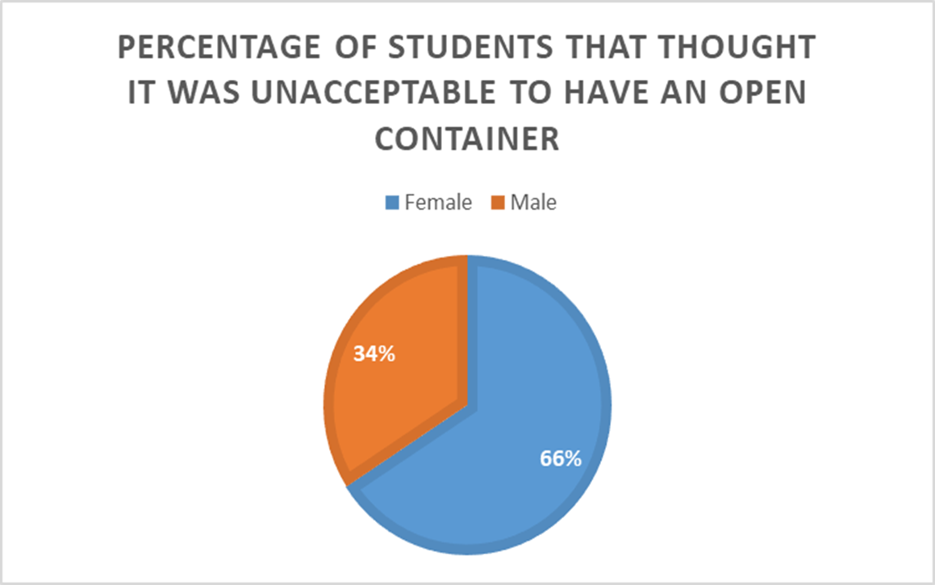

The second result to yield a significant factor was whether or not it was unacceptable to threaten a wildlife officer. Of the results complied Criminal Justice students ranked that offense as a higher fine unit 78% of the time whereas Non-Criminal Justice students ranked that offense lower in fine unit 22% of the time. Upon further digging into the results it was concluded that the vast majority of Non-Criminal Justice students were not aware that a wildlife officer holds the same status and authority as a patrol police officer.

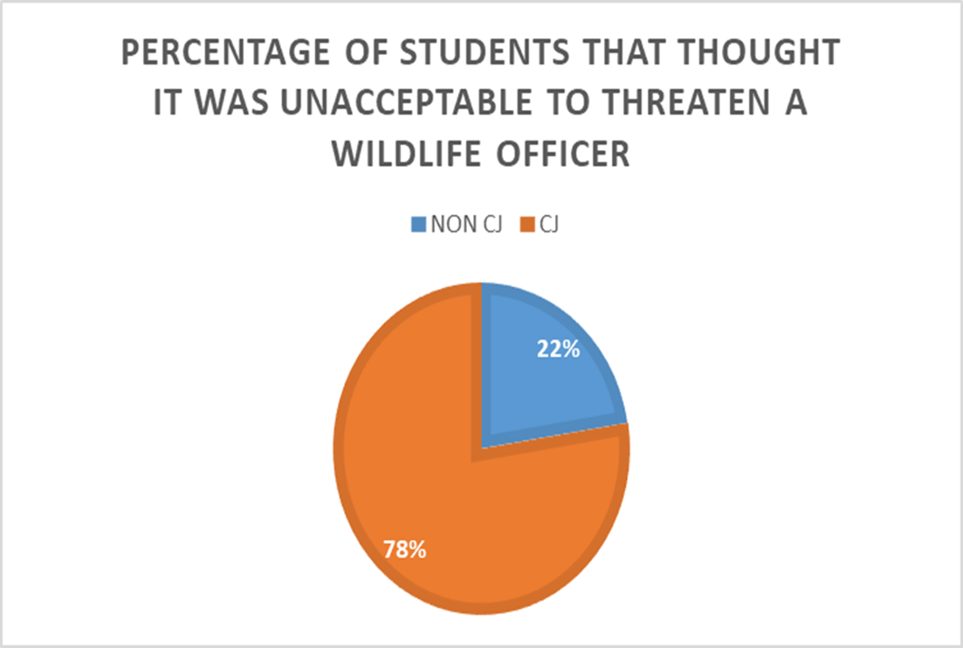

The third and final result to yield a significant factor that was focused on was whether or not it was unacceptable to raise a wild animal without a license. Of the results complied females ranked that offense as a higher fine unit 66% of the time whereas males ranked that offense lower in fine unit 34% of the time. Upon further reflection on the results it was determined the most commonly raised animal in a household without a license is a raccoon in Northwest Ohio.

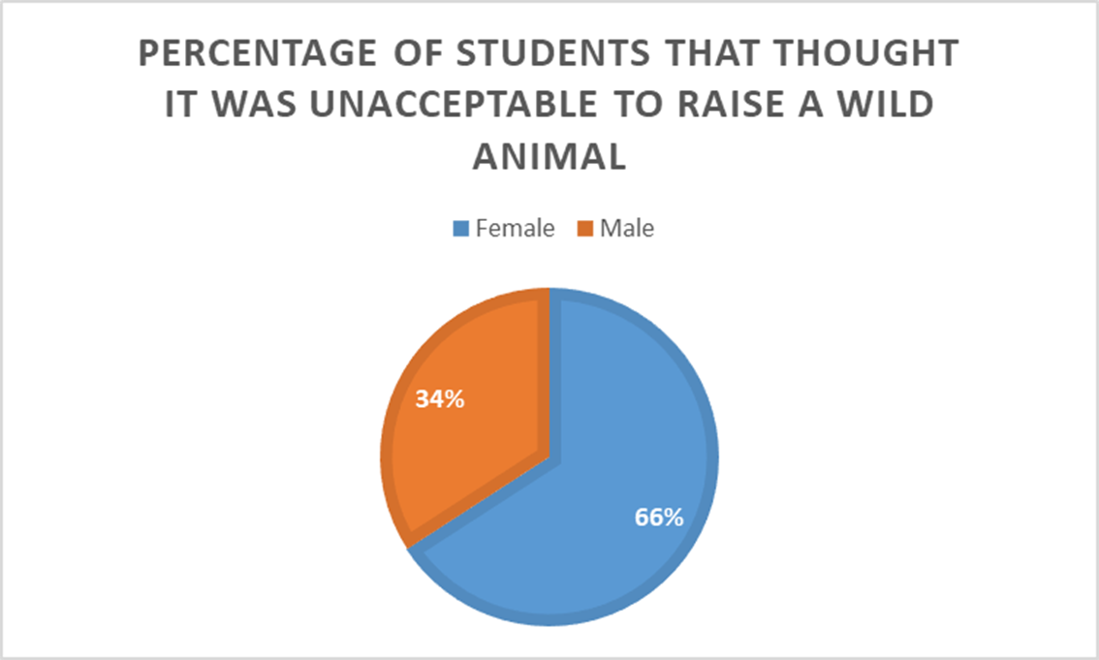

Conclusion

Most of the results were not significant at the .05 alpha level. A select few questions raised a significant result. Of those responses and questions that were significant we conducted a correlation test that produces a weak positive relationship. All of the results produced no negative relationships. Due to no negative relationships and a weak relationship being established that lead us to think of how we could have more significant data in the future when running the tests and doing more research on this topic. Our group discussed the need for more data as our results shown little significant results and the thought of more data would give us either more significant results or show a bigger need for more data.

We also discussed the need to reword some of the questions asked because many survey takers needed to ask for clarification on certain questions. Our group also discussed adding different variables to the survey. We would add the question of identifying your political affiliation to show a possible significant bipartisan agreeance and support of a day fine system implementation in the United States.

The limitations of our present study were revolving around the central problem of not having a big enough sample. To fix this limitation our group made notes to improve on going to more than one university. We discussed going to different universities in the same state or even surveying different universities in other states then the one presently in.

# References

Colgan, B. (2017). Graduating Economic Sanctions According to Ability to Pay. *Iowa Law Review*, 53-113. doi:126538168

Day, M., & Ross, M. (2011). The Value of Remorse: How Drivers' Responses to Police Predict Fines for Speeding. *Law and Human Behavior*, 221-234. doi:edsjsr.41488991

Drapal, J. (2018). Day fines: A European comparison and Czech malpractice. *European Journal of Criminology*, 461-480. doi:10.1177/1477370817749178

Eriksson, L., & Goodin, R. (2007). The Measuring Rod of Time: The Example of Swedish Day‐fines. *Journal of Applied Philosophy*. doi:10.1111/j.1468-5930.2007.00376.x

Hamilton, C. (2004). Making fines fairer. *THE AUSTRALIA INSTITUTE*, 1-3.

Kantorowicz-Reznichenko, E., & Kerk, M. (2015). Day Fines: Asymmetric Information and the Secondary Enforcement System. *Rotterdam Institute for Law and Economics*, 1-26.

McIvor, G., Pirnat, C., & Grafl, C. (2013). Unpaid work as an alternative to imprisonment for fine default in Austria and Scotland. *European Journal of Probation*, 3-28. doi:10.1177/206622031300500202

Schierenbeck, A. (2018). The Constitutionality of Income-Based Fines. *University of Chicago Law Review.*, 1869-1925. doi:134448518

SOBOL, N. (2017). FIGHTING FINES & FEES: BORROWING FROM CONSUMER LAW TO COMBAT CRIMINAL JUSTICE DEBT ABUSES. *University of Colorado Law Review*, 841-912. doi:134341324

Surprenant, C. (2019). Policing and Punishment for Profit. *Journal or Business Ethics*, 119-131. Retrieved from https://link.springer.com/article/10.1007%2Fs10551-017-3744-7